**Project Report**

**---------------------------------------------------------------------------------------------------------**

18AIC204T-**SOFTWARE ENGINEERING PRINCIPLES**

**II Year/III Semester**

**Academic Year: 2022 – 2023**

By

Soham Chaudhuri (RA2111047010209)

S. Shreyas (RA2111047010195)

Anusha Garg (RA2111047010232)

Sadiya Faiz Ahmed (RA2111047010218)

Aarthi P (RA2111047010212)

Nivetha K (RA2111047010255)

Under the guidance of

**Dr. SUDHA RAJESH**

**Associate Professor**

**Department of Computational Intelligence**



**FACULTY OF ENGINEERING AND TECHNOLOGY**

**SCHOOL OF COMPUTING**

**SRM INSTITUTE OF SCIENCE AND TECHNOLOGY**

**Kattankulathur, Kancheepuram**

**NOVEMBER 2022**

**Table of Contents**

|  |  |
| --- | --- |
| **Sr.no** | **Contents** |
|  | **Project Description** |
|  | **Project Overview and Abstract** |
|  | **Purpose of Project** |
|  | **The Scope of the work** |
|  | **Product Scenarios** |
|  | **Constraints** |
|  | **Naming conventions and Definitions** |
|  | **UML diagrams** |
|  | **Relevant Facts and Assumptions** |
|  | **Requirements** |
|  | **Design** |
|  | **Current Software Architecture (code)** |
|  | **Future development proposals** |
|  | **User Interface** |
|  | **Product Test Cases** |
|  | **Testing result of product** |
|  | **Pass/Fail Criteria** |
|  | **Testing materials** |
|  | **Project issues** |
|  | **Ideas for Solutions** |
|  | **Glossary** |
|  | **References/Bibliography** |

**1.Project Description**

The project “Nutritional Analytic App” is an application developed for monitoring and calculating the calorie in-take of an user. Lack of proper diet causes many diseases like night blindness, gum death, rickets, osteomalacia, etc. Similarly, undernutrition will cause a low intelligence quotient (IQ), osteoporosis, anemia, scurvy, pellagra, etc. Over-nutrition will result in obesity, Type II diabetes mellitus, and ischemic heart diseases. Also, the unhygienic intake of food, intake of food on no

of other unhealthy stuff can lead to irregularities in the human body. Many mobile applications were developed for monitoring and calculating an energy level as well as healthy nutrition. Many mobile applications were developed for monitoring and calculating an energy level as well as healthy nutrition. In the view of developing technology, changing lifestyles and busy schedules, people often tend to neglect their health. This has led to an outcry about health related issues among all age grou

The popularity and usage of Smartphone application leads to the need of an application that can cater to the need of health management amongst youngsters. This paper presents the details of a fully functional Android Application for health management specifically. The developed application solves the major practical problems faced during health management and meal intake. It is a application that uses Machine learning integration in a java made application which allows health maintenance based on local factors.

**2.Project Overview and Abstract**

The project “Nutritional analytical app” helps us to analysis data and use said data to aid users in the form of an app.

The project is built using python and java where data is used to train a machine learning model (ANN) to attain a way to predict one’s condition and given a report using application software. The data can also be used to analyse regional requirements so as to grant a more useful and effective result. The user interacts with the interface of the app and is helped by the machine learning neural network to give regional specific outputs. The user is to update his height and weight details. Accordingly he will be provided with the numerical value of his required calories. Simultaneously the user is also required to update his meals to make a count to the calories taken in. The app also subsequently generates a grocery list with required items for the meal plans. The app is also synced with the fitness tracker meanwhile to keep up with the progress of the user. This redundant process is followed everyday to achieve the monthly or quarterly targets set by the app for the user.

**3.Purpose of Project**

The purpose is to make application that a gives a person information based on regional specific data. This will improve health in each region and hence suggest a nutritional change.

**4.The scope of the work**

The work requires a scope of massive research work in fields of health differences in regional category

Also Research on the requirement to emphasize the regional health requirements due to environmental differences.

Use of the nutritional data and information acquired through the industry and what the industry is lacking and is required is also researched.

**5.Product Scenarios**

Project scenario: Malik has a busy lifestyle due to his overloaded work and monthly targets. Due to his preoccupation, he is unable to track his dietary requirements and maintain his health. Recently, during his annual check-up he finds out he is overweight and needs to attain the right BMI for a healthy life. So, Malik starts using the Nutritional analytic application. The app requires him to give the height and weight as inputs. He has to update his everyday meals in the app as it keeps a record of his calorie in-take. The app then makes a grocery list for him with accordance to the meal plan designed for him. He also syncs the app with his fitness tracker which gives him more accuracy in recording his everyday activities. In the end of each month, the app notifies him if he has accomplished to achieve his goals. After using the app for three months Malik makes a huge progress in his fitness goal and finally attains appropriate weight.

**6.Constraints**

the basic constraints that we forego in a software project is that :

1. Data constraint: we need to know how much data is there in our environment,

how much we can use, what we must not use, and on top of that, we also have to do data gathering in a

fast manner and I should be up to date.

2. CLUSTERING : we have to sort the data in an automatic manner or a manual way like using codes. manually proceeding

with clustering is like working solo to search or store for a book or file in a library of infinite number of books,'

without any proper reference number like year of publishment or serial number.

3. all data we collect wont be like matching every person who will be using the app. cause every single will have a

different taste, and we have to verify each and every factual information about the patient in order to check whether

the predicted diet in the app is good enough for his metabolism.

4. Application constraint is that, IOS, ANDROID, LINUX, etc... for each and everyone of these we have to make some

amends to compile our app in their interface. this will take a lot of time and a lot of man power.

5. Time Constraint : nowadays, coding is also like evolving into various platforms like python, java, react, javascript, c++, C, C#, PHP.

but in order to combine all the types or to choose which type we want, it will take a lot of time.

6. Market for selling : whatever advancement we do, the world is like having artificial intelligence in its hand right

now, so in the market there wont be a proper solo performance for us. we will be like of the thing in the line, waiting

to be sold. and ofcourse the more the competition the more the less the profit we gain in the queue.

**7.Naming Conventions and Definitions**

UML – Unified modelling language

It a way to visually represent the architecture, design, and implementation of complex software systems.

Nutrition –

It is the biochemical and physiological process by which an organism uses food to support its life. It provides organisms with nutrients, which can be metabolized to create energy and chemical structures. Failure to obtain sufficient nutrients causes malnutrition. Nutritional science is the study of nutrition, though it typically emphasizes human nutrition.

Nutritional analysis –

It refers to the process of determining the nutritional content

UI – User Interface

**8.UML diagrams**

Activity

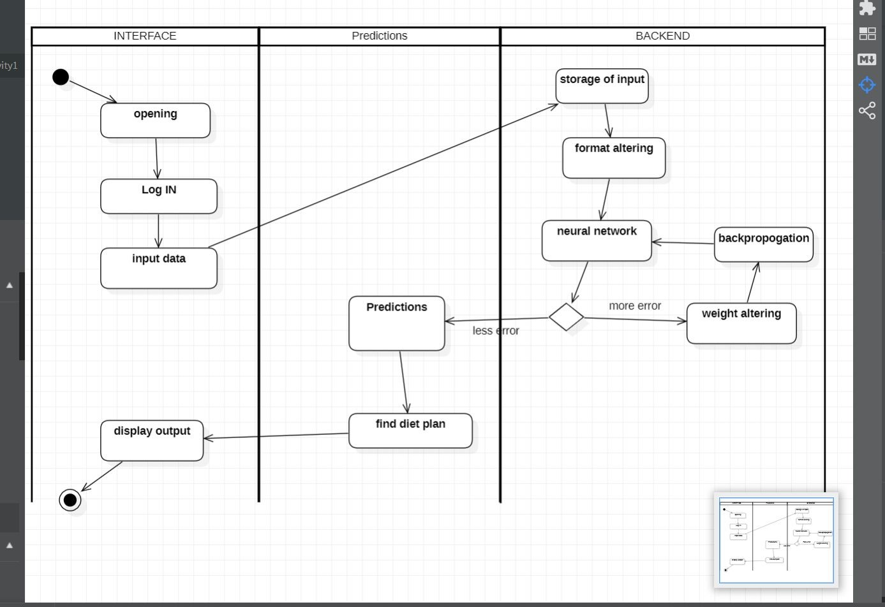

DFD

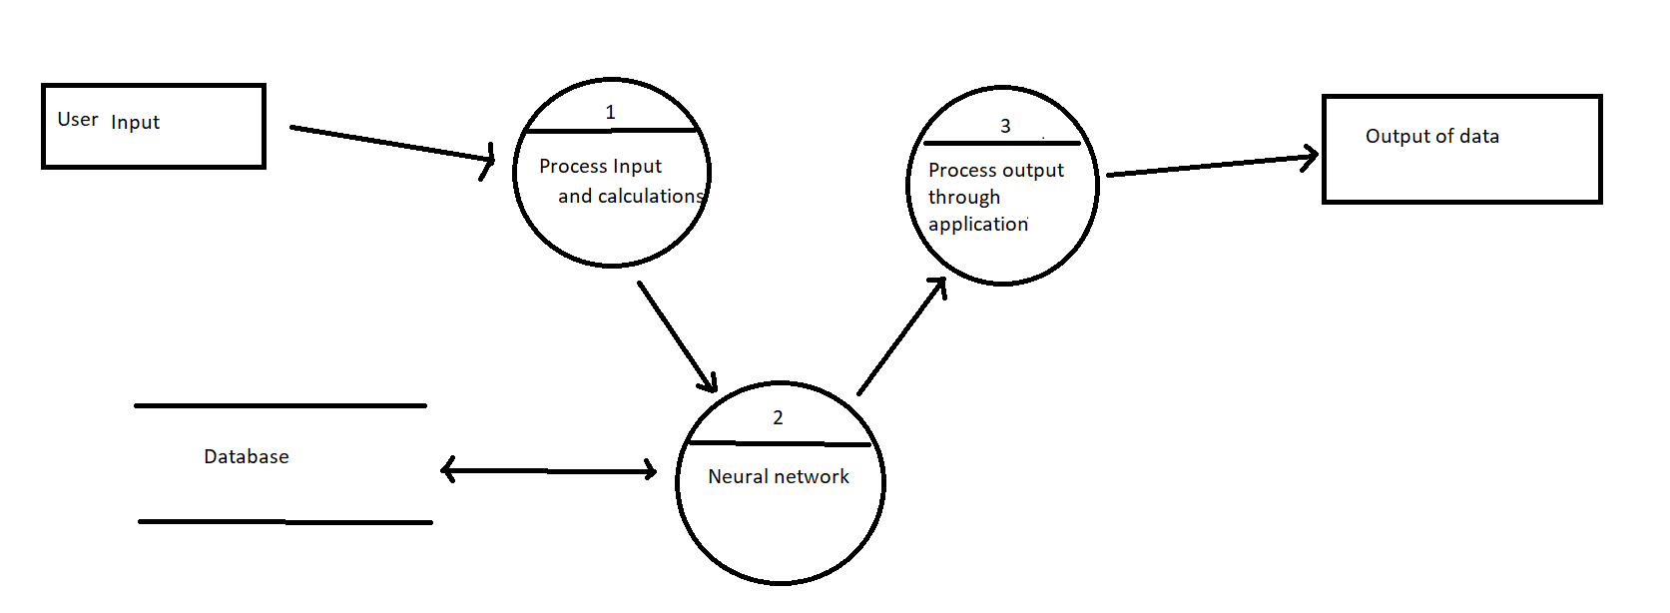

**9.Relevent Facts and Assumptions**

## There Is No Perfect Diet for Everyone

People are all unique. Subtle differences in genetics, body type, physical activity and environment can affect which type of diet you should follow.

Some people do best on a low-carb diet, while others are better off on a vegetarian high-carb diet.

The fact is, what works for one person may not work for the next.

To figure out what you should do, a little experimentation may be needed.

Try a few different things until you find something that you enjoy and think you can stick to. Different strokes for different folks!

* A healthy diet helps to protect against malnutrition in all its forms, as well as noncommunicable diseases (NCDs), including diabetes, heart disease, stroke and cancer.
* Unhealthy diet and lack of physical activity are leading global risks to health.
* Healthy dietary practices start early in life – breastfeeding fosters healthy growth and improves cognitive development, and may have longer term health benefits such as reducing the risk of becoming overweight or obese and developing NCDs later in life.
* Energy intake (calories) should be in balance with energy expenditure. To avoid unhealthy weight gain, total fat should not exceed 30% of total energy intake (1, 2, 3). Intake of saturated fats should be less than 10% of total energy intake, and intake of trans-fats less than 1% of total energy intake, with a shift in fat consumption away from saturated fats and trans-fats to unsaturated fats (3), and towards the goal of eliminating industrially-produced trans-fats.
* Limiting intake of free sugars to less than 10% of total energy intake (2, 7) is part of a healthy diet. A further reduction to less than 5% of total energy intake is suggested for additional health benefits.
* Keeping salt intake to less than 5 g per day (equivalent to sodium intake of less than 2 g per day) helps to prevent hypertension, and reduces the risk of heart disease and stroke in the adult population.
* WHO Member States have agreed to reduce the global population’s intake of salt by 30% by 2025; they have also agreed to halt the rise in diabetes and obesity in adults and adolescents as well as in childhood overweight by 2025 .

## In 2020, between 720 and 811 million people faced hunger

The number of people in the world affected by hunger increased in 2020 under the shadow of the COVID-19 pandemic. After remaining virtually unchanged from 2014 to 2019, the prevalence of undernourishment (PoU) climbed to around 9.9 percent in 2020, from 8.4 percent a year earlier.

In terms of population, taking into consideration the additional statistical uncertainty, it is estimated that between 720 and 811 million people in the world faced hunger in 2020. Considering the middle of the projected range (768 million), 118 million more people were facing hunger in 2020 than in 2019 – or as many as 161 million, considering the upper bound of the range.

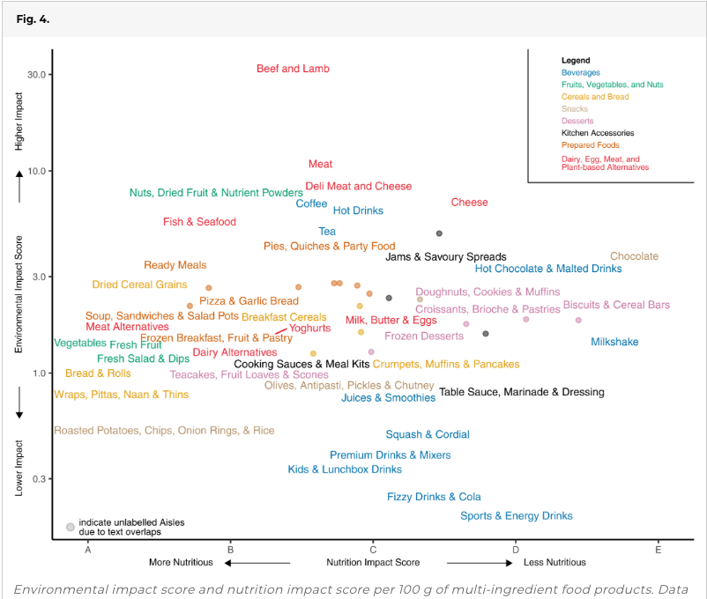

And thus taking account of all these facts, we assure some practical advices to maintain a healthy diet through our app(project). For example,

* Eating at least 400 g, or five portions, of fruit and vegetables per day reduces the risk of NCDs (2) and helps to ensure an adequate daily intake of dietary fibre. ;
* Reducing the amount of total fat intake to less than 30% of total energy intake helps to prevent unhealthy weight gain in the adult population ;
* Reducing salt intake to the recommended level of less than 5 g per day could prevent 1.7 million deaths each year, ETC…………

**10.Requirements**

**Functional requirements-**

• Strategically analysing the nutrient deficiency in the community or the targeted group.

• In order to provide accurate solutions to identified problems.

• The app records the calorie count and gives the provisional details in accordance with the height and weight of the user.

• In addition to the other features, it also takes account of macronutrients such as carbohydrates and protein to devise an appropriate diet.

• Highlight feature is the integration of the app with the fitness trackers to have more enhanced implementation of the project in day to day use.

**Non-Functional Requirement-**

• We, require and compiler and an environment to run the application .An in-app data set trained model. In this section, the app is provided with a bucket of labelled data which are shared and suggested by various in-app nutritionists on a daily basis.

• We require appropriate memory space and data, as In the world of competition and everyone trying to beat the others, this keeps the users happy and determined to keep on top.

• Connecting feature requires permission from the phone with experts or nutritional professionals for a more practical approach to the plan.

• A processor and graphical unit are necessary so as function.

**11.Design**

The design goal for this project is to have a simple UI and a complex Backend to give the most helpful support while not complicating things further.

The software design consists of integration of neural network with app development to give a app that can function with the help of neural network models to give output based on prediction of certain aspects on the basis of other elements.

Use of icons and sliders in frontend aspects do provide more interactivity and has made the experience of the application more effective.

**12.Current Software Architecture(code)**

-Machine learning and analysis

import pandas as pd  
import numpy as np  
from scipy import stats   
import seaborn as sns

df = pd.read_csv("diabetes.csv")  
df.head()

Pregnancies Glucose BloodPressure SkinThickness Insulin BMI \  
0 6 148 72 35 0 33.6   
1 1 85 66 29 0 26.6   
2 8 183 64 0 0 23.3   
3 1 89 66 23 94 28.1   
4 0 137 40 35 168 43.1   
  
 DiabetesPedigreeFunction Age Outcome   
0 0.627 50 1   
1 0.351 31 0   
2 0.672 32 1   
3 0.167 21 0   
4 2.288 33 1

df.describe()

Pregnancies Glucose BloodPressure SkinThickness Insulin \  
count 768.000000 768.000000 768.000000 768.000000 768.000000   
mean 3.845052 120.894531 69.105469 20.536458 79.799479   
std 3.369578 31.972618 19.355807 15.952218 115.244002   
min 0.000000 0.000000 0.000000 0.000000 0.000000   
25% 1.000000 99.000000 62.000000 0.000000 0.000000   
50% 3.000000 117.000000 72.000000 23.000000 30.500000   
75% 6.000000 140.250000 80.000000 32.000000 127.250000   
max 17.000000 199.000000 122.000000 99.000000 846.000000   
  
 BMI DiabetesPedigreeFunction Age Outcome   
count 768.000000 768.000000 768.000000 768.000000   
mean 31.992578 0.471876 33.240885 0.348958   
std 7.884160 0.331329 11.760232 0.476951   
min 0.000000 0.078000 21.000000 0.000000   
25% 27.300000 0.243750 24.000000 0.000000   
50% 32.000000 0.372500 29.000000 0.000000   
75% 36.600000 0.626250 41.000000 1.000000   
max 67.100000 2.420000 81.000000 1.000000

df.info()

<class 'pandas.core.frame.DataFrame'>  
RangeIndex: 768 entries, 0 to 767  
Data columns (total 9 columns):  
 # Column Non-Null Count Dtype   
--- ------ -------------- -----   
 0 Pregnancies 768 non-null int64   
 1 Glucose 768 non-null int64   
 2 BloodPressure 768 non-null int64   
 3 SkinThickness 768 non-null int64   
 4 Insulin 768 non-null int64   
 5 BMI 768 non-null float64  
 6 DiabetesPedigreeFunction 768 non-null float64  
 7 Age 768 non-null int64   
 8 Outcome 768 non-null int64   
dtypes: float64(2), int64(7)  
memory usage: 54.1 KB

df.isnull().sum()

Pregnancies 0  
Glucose 0  
BloodPressure 0  
SkinThickness 0  
Insulin 0  
BMI 0  
DiabetesPedigreeFunction 0  
Age 0  
Outcome 0  
dtype: int64

df=df.drop_duplicates()  
df.head()

Pregnancies Glucose BloodPressure SkinThickness Insulin BMI \  
0 6 148 72 35 0 33.6   
1 1 85 66 29 0 26.6   
2 8 183 64 0 0 23.3   
3 1 89 66 23 94 28.1   
4 0 137 40 35 168 43.1   
  
 DiabetesPedigreeFunction Age Outcome   
0 0.627 50 1   
1 0.351 31 0   
2 0.672 32 1   
3 0.167 21 0   
4 2.288 33 1

df.describe()

Pregnancies Glucose BloodPressure SkinThickness Insulin \  
count 768.000000 768.000000 768.000000 768.000000 768.000000   
mean 3.845052 120.894531 69.105469 20.536458 79.799479   
std 3.369578 31.972618 19.355807 15.952218 115.244002   
min 0.000000 0.000000 0.000000 0.000000 0.000000   
25% 1.000000 99.000000 62.000000 0.000000 0.000000   
50% 3.000000 117.000000 72.000000 23.000000 30.500000   
75% 6.000000 140.250000 80.000000 32.000000 127.250000   
max 17.000000 199.000000 122.000000 99.000000 846.000000   
  
 BMI DiabetesPedigreeFunction Age Outcome   
count 768.000000 768.000000 768.000000 768.000000   
mean 31.992578 0.471876 33.240885 0.348958   
std 7.884160 0.331329 11.760232 0.476951   
min 0.000000 0.078000 21.000000 0.000000   
25% 27.300000 0.243750 24.000000 0.000000   
50% 32.000000 0.372500 29.000000 0.000000   
75% 36.600000 0.626250 41.000000 1.000000   
max 67.100000 2.420000 81.000000 1.000000

df2=df.copy()  
list=['Glucose','BloodPressure','SkinThickness','Insulin','BMI','DiabetesPedigreeFunction','Age','Pregnancies']

df_std = df2.copy(deep=True)  
for column in list:  
 df_std[column] = (df_std[column] - df_std[column].mean()) / df_std[column].std()   
df=df_std  
df.head()

Pregnancies Glucose BloodPressure SkinThickness Insulin BMI \  
0 0.639530 0.847771 0.149543 0.906679 -0.692439 0.203880   
1 -0.844335 -1.122665 -0.160441 0.530556 -0.692439 -0.683976   
2 1.233077 1.942458 -0.263769 -1.287373 -0.692439 -1.102537   
3 -0.844335 -0.997558 -0.160441 0.154433 0.123221 -0.493721   
4 -1.141108 0.503727 -1.503707 0.906679 0.765337 1.408828   
  
 DiabetesPedigreeFunction Age Outcome   
0 0.468187 1.425067 1   
1 -0.364823 -0.190548 0   
2 0.604004 -0.105515 1   
3 -0.920163 -1.040871 0   
4 5.481337 -0.020483 1

x=df["Outcome"] #train  
y=df.drop(["Outcome"],axis=1)  
x1=df2["Outcome"] #test  
y1=df2.drop(["Outcome"],axis=1)

from sklearn.model_selection import train_test_split  
xtrain,xtest,ytrain,ytest= train_test_split(y,x,test_size=0.15,stratify=x)  
print(xtrain.shape)  
print(xtest.shape)  
print(ytrain.shape)  
print(ytest.shape)

(652, 8)  
(116, 8)  
(652,)  
(116,)

df_class_0 = df[df['Outcome'] == 0]  
df_class_1 = df[df['Outcome'] == 1]

df_n_class_0 = df2[df2['Outcome'] == 0]  
df_n_class_1 = df2[df2['Outcome'] == 1]

df_class_1_over = df_class_1.sample(500, replace=True)  
df_test_over = pd.concat([df_class_0, df_class_1_over], axis=0)

df_n_class_1_over = df_n_class_1.sample(500, replace=True)  
df_test_n_over = pd.concat([df_n_class_0, df_n_class_1_over], axis=0)  
df_test_n_over.describe()

Pregnancies Glucose BloodPressure SkinThickness Insulin \  
count 1000.000000 1000.000000 1000.00000 1000.00000 1000.000000   
mean 4.069000 125.376000 68.65500 21.37600 91.243000   
std 3.520033 32.813585 21.25384 16.30529 127.852737   
min 0.000000 0.000000 0.00000 0.00000 0.000000   
25% 1.000000 102.000000 62.00000 0.00000 0.000000   
50% 3.000000 122.000000 72.00000 24.00000 44.500000   
75% 7.000000 146.000000 80.00000 34.00000 145.000000   
max 17.000000 199.000000 122.00000 99.00000 846.000000   
  
 BMI DiabetesPedigreeFunction Age Outcome   
count 1000.000000 1000.000000 1000.000000 1000.00000   
mean 32.608600 0.478875 34.378000 0.50000   
std 7.659063 0.331731 11.678763 0.50025   
min 0.000000 0.078000 21.000000 0.00000   
25% 28.000000 0.247000 25.000000 0.00000   
50% 32.400000 0.380500 31.000000 0.50000   
75% 37.200000 0.640000 42.000000 1.00000   
max 67.100000 2.420000 81.000000 1.00000

y1=df_test_over['Outcome']  
df_test_over=df_test_over.drop(['Outcome'],axis=1)  
X1=df_test_over

y1_2=df_test_n_over['Outcome']  
df_test_n_over=df_test_n_over.drop(['Outcome'],axis=1)  
X1_2=df_test_n_over

from sklearn.model_selection import train_test_split  
  
X1_s_train,X1_s_test ,y1_s_train, y1_s_test = train_test_split(X1,y1,test_size=0.2,random_state=0,shuffle= True,stratify = y1)  
print('training data shape is :{}.'.format(X1_s_train.shape))  
print('training label shape is :{}.'.format(y1_s_train.shape))  
print('testing data shape is :{}.'.format(X1_s_test.shape))  
print('testing label shape is :{}.'.format(y1_s_test.shape))

training data shape is :(800, 8).  
training label shape is :(800,).  
testing data shape is :(200, 8).  
testing label shape is :(200,).

from sklearn.model_selection import train_test_split  
  
X1_s_n_train,X1_s_n_test ,y1_s_n_train, y1_s_n_test = train_test_split(X1_2,y1_2,test_size=0.2,random_state=0,shuffle = True,stratify = y1_2)

from tensorflow.keras import Sequential  
import tensorflow as tf  
from tensorflow.keras.layers import Dense,Dropout  
m=Sequential()  
m.add(Dense(256, activation = 'relu' ,input_shape=([8])))   
m.add(Dense(256, activation = 'relu'))  
m.add(Dense(1,activation = 'sigmoid'))  
m.compile(optimizer= 'adam', loss= 'binary_crossentropy',metrics= ['accuracy','Precision','Recall','AUC'])  
epochs = 50  
m.fit(X1_s_train ,y1_s_train,epochs= epochs,steps_per_epoch=200,validation_data=(X1_s_test ,y1_s_test))

Epoch 1/50  
200/200 [==============================] - 2s 4ms/step - loss: 0.5420 - accuracy: 0.7450 - precision: 0.7475 - recall: 0.7400 - auc: 0.8092 - val_loss: 0.4658 - val_accuracy: 0.7850 - val_precision: 0.8353 - val_recall: 0.7100 - val_auc: 0.8764  
Epoch 2/50  
200/200 [==============================] - 1s 3ms/step - loss: 0.4928 - accuracy: 0.7475 - precision: 0.7487 - recall: 0.7450 - auc: 0.8412 - val_loss: 0.4148 - val_accuracy: 0.8400 - val_precision: 0.8333 - val_recall: 0.8500 - val_auc: 0.8928  
Epoch 3/50  
200/200 [==============================] - 1s 3ms/step - loss: 0.4699 - accuracy: 0.7725 - precision: 0.7698 - recall: 0.7775 - auc: 0.8584 - val_loss: 0.4016 - val_accuracy: 0.8550 - val_precision: 0.8586 - val_recall: 0.8500 - val_auc: 0.8961  
Epoch 4/50  
200/200 [==============================] - 0s 2ms/step - loss: 0.4533 - accuracy: 0.7887 - precision: 0.7824 - recall: 0.8000 - auc: 0.8693 - val_loss: 0.3902 - val_accuracy: 0.8500 - val_precision: 0.8646 - val_recall: 0.8300 - val_auc: 0.9069  
Epoch 5/50  
200/200 [==============================] - 1s 3ms/step - loss: 0.4524 - accuracy: 0.7887 - precision: 0.7852 - recall: 0.7950 - auc: 0.8703 - val_loss: 0.4011 - val_accuracy: 0.8650 - val_precision: 0.8842 - val_recall: 0.8400 - val_auc: 0.9191  
Epoch 6/50  
200/200 [==============================] - 0s 2ms/step - loss: 0.4355 - accuracy: 0.7975 - precision: 0.7946 - recall: 0.8025 - auc: 0.8790 - val_loss: 0.3858 - val_accuracy: 0.8250 - val_precision: 0.8571 - val_recall: 0.7800 - val_auc: 0.9092  
Epoch 7/50  
200/200 [==============================] - 0s 2ms/step - loss: 0.4184 - accuracy: 0.8112 - precision: 0.8059 - recall: 0.8200 - auc: 0.8911 - val_loss: 0.3874 - val_accuracy: 0.8500 - val_precision: 0.8070 - val_recall: 0.9200 - val_auc: 0.9092  
Epoch 8/50  
200/200 [==============================] - 1s 4ms/step - loss: 0.4114 - accuracy: 0.8050 - precision: 0.7961 - recall: 0.8200 - auc: 0.8929 - val_loss: 0.3681 - val_accuracy: 0.8600 - val_precision: 0.8529 - val_recall: 0.8700 - val_auc: 0.9137  
Epoch 9/50  
200/200 [==============================] - 1s 4ms/step - loss: 0.3944 - accuracy: 0.8313 - precision: 0.8132 - recall: 0.8600 - auc: 0.9030 - val_loss: 0.3655 - val_accuracy: 0.8700 - val_precision: 0.8700 - val_recall: 0.8700 - val_auc: 0.9178  
Epoch 10/50  
200/200 [==============================] - 1s 3ms/step - loss: 0.3780 - accuracy: 0.8350 - precision: 0.8333 - recall: 0.8375 - auc: 0.9119 - val_loss: 0.3764 - val_accuracy: 0.8750 - val_precision: 0.8440 - val_recall: 0.9200 - val_auc: 0.9045  
Epoch 11/50  
200/200 [==============================] - 1s 4ms/step - loss: 0.3760 - accuracy: 0.8300 - precision: 0.8220 - recall: 0.8425 - auc: 0.9116 - val_loss: 0.3756 - val_accuracy: 0.8500 - val_precision: 0.8302 - val_recall: 0.8800 - val_auc: 0.9093  
Epoch 12/50  
200/200 [==============================] - 1s 4ms/step - loss: 0.3449 - accuracy: 0.8550 - precision: 0.8463 - recall: 0.8675 - auc: 0.9290 - val_loss: 0.3761 - val_accuracy: 0.8500 - val_precision: 0.8365 - val_recall: 0.8700 - val_auc: 0.9087  
Epoch 13/50  
200/200 [==============================] - 0s 2ms/step - loss: 0.3233 - accuracy: 0.8587 - precision: 0.8345 - recall: 0.8950 - auc: 0.9362 - val_loss: 0.3656 - val_accuracy: 0.8700 - val_precision: 0.8776 - val_recall: 0.8600 - val_auc: 0.9146  
Epoch 14/50  
200/200 [==============================] - 0s 2ms/step - loss: 0.3050 - accuracy: 0.8725 - precision: 0.8688 - recall: 0.8775 - auc: 0.9450 - val_loss: 0.4000 - val_accuracy: 0.8600 - val_precision: 0.8273 - val_recall: 0.9100 - val_auc: 0.9029  
Epoch 15/50  
200/200 [==============================] - 1s 3ms/step - loss: 0.2933 - accuracy: 0.8775 - precision: 0.8665 - recall: 0.8925 - auc: 0.9485 - val_loss: 0.4055 - val_accuracy: 0.8450 - val_precision: 0.8485 - val_recall: 0.8400 - val_auc: 0.9017  
Epoch 16/50  
200/200 [==============================] - 1s 4ms/step - loss: 0.2871 - accuracy: 0.8863 - precision: 0.8705 - recall: 0.9075 - auc: 0.9513 - val_loss: 0.4662 - val_accuracy: 0.8350 - val_precision: 0.8764 - val_recall: 0.7800 - val_auc: 0.8965  
Epoch 17/50  
200/200 [==============================] - 1s 3ms/step - loss: 0.2786 - accuracy: 0.8763 - precision: 0.8680 - recall: 0.8875 - auc: 0.9539 - val_loss: 0.4356 - val_accuracy: 0.8150 - val_precision: 0.8706 - val_recall: 0.7400 - val_auc: 0.9104  
Epoch 18/50  
200/200 [==============================] - 0s 2ms/step - loss: 0.2530 - accuracy: 0.9000 - precision: 0.8980 - recall: 0.9025 - auc: 0.9628 - val_loss: 0.4477 - val_accuracy: 0.8150 - val_precision: 0.8621 - val_recall: 0.7500 - val_auc: 0.9023  
Epoch 19/50  
200/200 [==============================] - 0s 2ms/step - loss: 0.2325 - accuracy: 0.9100 - precision: 0.8961 - recall: 0.9275 - auc: 0.9698 - val_loss: 0.4313 - val_accuracy: 0.8150 - val_precision: 0.8182 - val_recall: 0.8100 - val_auc: 0.8941  
Epoch 20/50  
200/200 [==============================] - 0s 2ms/step - loss: 0.2210 - accuracy: 0.9150 - precision: 0.9049 - recall: 0.9275 - auc: 0.9727 - val_loss: 0.4453 - val_accuracy: 0.8400 - val_precision: 0.8208 - val_recall: 0.8700 - val_auc: 0.8946  
Epoch 21/50  
200/200 [==============================] - 0s 2ms/step - loss: 0.2007 - accuracy: 0.9150 - precision: 0.9089 - recall: 0.9225 - auc: 0.9786 - val_loss: 0.4616 - val_accuracy: 0.8350 - val_precision: 0.8131 - val_recall: 0.8700 - val_auc: 0.8851  
Epoch 22/50  
200/200 [==============================] - 0s 2ms/step - loss: 0.1901 - accuracy: 0.9237 - precision: 0.9084 - recall: 0.9425 - auc: 0.9818 - val_loss: 0.4584 - val_accuracy: 0.8400 - val_precision: 0.8542 - val_recall: 0.8200 - val_auc: 0.9061  
Epoch 23/50  
200/200 [==============================] - 0s 2ms/step - loss: 0.1788 - accuracy: 0.9375 - precision: 0.9289 - recall: 0.9475 - auc: 0.9820 - val_loss: 0.5191 - val_accuracy: 0.8100 - val_precision: 0.8100 - val_recall: 0.8100 - val_auc: 0.8777  
Epoch 24/50  
200/200 [==============================] - 0s 2ms/step - loss: 0.1753 - accuracy: 0.9312 - precision: 0.9238 - recall: 0.9400 - auc: 0.9831 - val_loss: 0.5436 - val_accuracy: 0.7900 - val_precision: 0.7843 - val_recall: 0.8000 - val_auc: 0.8839  
Epoch 25/50  
200/200 [==============================] - 1s 4ms/step - loss: 0.1686 - accuracy: 0.9400 - precision: 0.9272 - recall: 0.9550 - auc: 0.9845 - val_loss: 0.6092 - val_accuracy: 0.8000 - val_precision: 0.7778 - val_recall: 0.8400 - val_auc: 0.8664  
Epoch 26/50  
200/200 [==============================] - 1s 3ms/step - loss: 0.1557 - accuracy: 0.9450 - precision: 0.9300 - recall: 0.9625 - auc: 0.9879 - val_loss: 0.5537 - val_accuracy: 0.8200 - val_precision: 0.8333 - val_recall: 0.8000 - val_auc: 0.8946  
Epoch 27/50  
200/200 [==============================] - 1s 3ms/step - loss: 0.1494 - accuracy: 0.9525 - precision: 0.9480 - recall: 0.9575 - auc: 0.9877 - val_loss: 0.6204 - val_accuracy: 0.8150 - val_precision: 0.8247 - val_recall: 0.8000 - val_auc: 0.8765  
Epoch 28/50  
200/200 [==============================] - 1s 3ms/step - loss: 0.1183 - accuracy: 0.9625 - precision: 0.9557 - recall: 0.9700 - auc: 0.9937 - val_loss: 0.6012 - val_accuracy: 0.8100 - val_precision: 0.7925 - val_recall: 0.8400 - val_auc: 0.8882  
Epoch 29/50  
200/200 [==============================] - 0s 2ms/step - loss: 0.1185 - accuracy: 0.9588 - precision: 0.9487 - recall: 0.9700 - auc: 0.9934 - val_loss: 0.6682 - val_accuracy: 0.8100 - val_precision: 0.7925 - val_recall: 0.8400 - val_auc: 0.8833  
Epoch 30/50  
200/200 [==============================] - 0s 2ms/step - loss: 0.1203 - accuracy: 0.9513 - precision: 0.9392 - recall: 0.9650 - auc: 0.9935 - val_loss: 0.6510 - val_accuracy: 0.8250 - val_precision: 0.8095 - val_recall: 0.8500 - val_auc: 0.8786  
Epoch 31/50  
200/200 [==============================] - 0s 2ms/step - loss: 0.0940 - accuracy: 0.9725 - precision: 0.9773 - recall: 0.9675 - auc: 0.9962 - val_loss: 0.6995 - val_accuracy: 0.8050 - val_precision: 0.7850 - val_recall: 0.8400 - val_auc: 0.8682  
Epoch 32/50  
200/200 [==============================] - 0s 2ms/step - loss: 0.1059 - accuracy: 0.9750 - precision: 0.9703 - recall: 0.9800 - auc: 0.9922 - val_loss: 0.6982 - val_accuracy: 0.8250 - val_precision: 0.8421 - val_recall: 0.8000 - val_auc: 0.8770  
Epoch 33/50  
200/200 [==============================] - 0s 2ms/step - loss: 0.0943 - accuracy: 0.9688 - precision: 0.9630 - recall: 0.9750 - auc: 0.9962 - val_loss: 0.6609 - val_accuracy: 0.8350 - val_precision: 0.8252 - val_recall: 0.8500 - val_auc: 0.8900  
Epoch 34/50  
200/200 [==============================] - 0s 2ms/step - loss: 0.0889 - accuracy: 0.9737 - precision: 0.9679 - recall: 0.9800 - auc: 0.9955 - val_loss: 0.7283 - val_accuracy: 0.8200 - val_precision: 0.8200 - val_recall: 0.8200 - val_auc: 0.8815  
Epoch 35/50  
200/200 [==============================] - 0s 2ms/step - loss: 0.0675 - accuracy: 0.9837 - precision: 0.9825 - recall: 0.9850 - auc: 0.9981 - val_loss: 0.7629 - val_accuracy: 0.7950 - val_precision: 0.8105 - val_recall: 0.7700 - val_auc: 0.8705  
Epoch 36/50  
200/200 [==============================] - 0s 2ms/step - loss: 0.0603 - accuracy: 0.9837 - precision: 0.9825 - recall: 0.9850 - auc: 0.9991 - val_loss: 0.7677 - val_accuracy: 0.8050 - val_precision: 0.7748 - val_recall: 0.8600 - val_auc: 0.8742  
Epoch 37/50  
200/200 [==============================] - 0s 2ms/step - loss: 0.0620 - accuracy: 0.9812 - precision: 0.9825 - recall: 0.9800 - auc: 0.9990 - val_loss: 0.7461 - val_accuracy: 0.8050 - val_precision: 0.8020 - val_recall: 0.8100 - val_auc: 0.8748  
Epoch 38/50  
200/200 [==============================] - 0s 2ms/step - loss: 0.0615 - accuracy: 0.9812 - precision: 0.9777 - recall: 0.9850 - auc: 0.9987 - val_loss: 0.7908 - val_accuracy: 0.8300 - val_precision: 0.8235 - val_recall: 0.8400 - val_auc: 0.8875  
Epoch 39/50  
200/200 [==============================] - 0s 2ms/step - loss: 0.0477 - accuracy: 0.9937 - precision: 0.9901 - recall: 0.9975 - auc: 0.9991 - val_loss: 0.8780 - val_accuracy: 0.8200 - val_precision: 0.8077 - val_recall: 0.8400 - val_auc: 0.8684  
Epoch 40/50  
200/200 [==============================] - 0s 2ms/step - loss: 0.0455 - accuracy: 0.9875 - precision: 0.9851 - recall: 0.9900 - auc: 0.9994 - val_loss: 0.9226 - val_accuracy: 0.8100 - val_precision: 0.7925 - val_recall: 0.8400 - val_auc: 0.8669  
Epoch 41/50  
200/200 [==============================] - 1s 3ms/step - loss: 0.0454 - accuracy: 0.9887 - precision: 0.9900 - recall: 0.9875 - auc: 0.9991 - val_loss: 0.8897 - val_accuracy: 0.8150 - val_precision: 0.8119 - val_recall: 0.8200 - val_auc: 0.8704  
Epoch 42/50  
200/200 [==============================] - 0s 2ms/step - loss: 0.0354 - accuracy: 0.9912 - precision: 0.9925 - recall: 0.9900 - auc: 0.9997 - val_loss: 0.9486 - val_accuracy: 0.8150 - val_precision: 0.8000 - val_recall: 0.8400 - val_auc: 0.8717  
Epoch 43/50  
200/200 [==============================] - 1s 3ms/step - loss: 0.0266 - accuracy: 0.9950 - precision: 0.9950 - recall: 0.9950 - auc: 0.9999 - val_loss: 0.9424 - val_accuracy: 0.8000 - val_precision: 0.8061 - val_recall: 0.7900 - val_auc: 0.8714  
Epoch 44/50  
200/200 [==============================] - 0s 2ms/step - loss: 0.0299 - accuracy: 0.9937 - precision: 0.9925 - recall: 0.9950 - auc: 0.9998 - val_loss: 0.9837 - val_accuracy: 0.8100 - val_precision: 0.8298 - val_recall: 0.7800 - val_auc: 0.8705  
Epoch 45/50  
200/200 [==============================] - 0s 2ms/step - loss: 0.0271 - accuracy: 0.9912 - precision: 0.9900 - recall: 0.9925 - auc: 0.9999 - val_loss: 0.9751 - val_accuracy: 0.8000 - val_precision: 0.7941 - val_recall: 0.8100 - val_auc: 0.8747  
Epoch 46/50  
200/200 [==============================] - 0s 2ms/step - loss: 0.0470 - accuracy: 0.9875 - precision: 0.9875 - recall: 0.9875 - auc: 0.9979 - val_loss: 1.0697 - val_accuracy: 0.7750 - val_precision: 0.7570 - val_recall: 0.8100 - val_auc: 0.8530  
Epoch 47/50  
200/200 [==============================] - 0s 2ms/step - loss: 0.1402 - accuracy: 0.9550 - precision: 0.9505 - recall: 0.9600 - auc: 0.9873 - val_loss: 0.9960 - val_accuracy: 0.8150 - val_precision: 0.7944 - val_recall: 0.8500 - val_auc: 0.8684  
Epoch 48/50  
200/200 [==============================] - 0s 2ms/step - loss: 0.0489 - accuracy: 0.9837 - precision: 0.9850 - recall: 0.9825 - auc: 0.9993 - val_loss: 1.0300 - val_accuracy: 0.8250 - val_precision: 0.8421 - val_recall: 0.8000 - val_auc: 0.8713  
Epoch 49/50  
200/200 [==============================] - 0s 2ms/step - loss: 0.0267 - accuracy: 0.9962 - precision: 0.9950 - recall: 0.9975 - auc: 0.9999 - val_loss: 0.9619 - val_accuracy: 0.8050 - val_precision: 0.8020 - val_recall: 0.8100 - val_auc: 0.8857  
Epoch 50/50  
200/200 [==============================] - 0s 2ms/step - loss: 0.0207 - accuracy: 0.9962 - precision: 0.9950 - recall: 0.9975 - auc: 0.9999 - val_loss: 1.0055 - val_accuracy: 0.8250 - val_precision: 0.8351 - val_recall: 0.8100 - val_auc: 0.8799

<keras.callbacks.History at 0x19ef8f06920>

c = tf.lite.TFLiteConverter.from_keras_model(m)  
tf_lite=c.convert()  
with open('sep.tflite', 'wb') as f:  
 f.write(tf_lite)

INFO:tensorflow:Assets written to: C:\Users\hp\AppData\Local\Temp\tmp46ibl7tq\a

-Application

Backend code

|  |
| --- |
| package com.example.bmicalculator; |
|  |  |
|  | import androidx.appcompat.app.AppCompatActivity; |
|  | import androidx.core.content.ContextCompat; |
|  |  |
|  | import android.annotation.SuppressLint; |
|  | import android.content.Intent; |
|  | import android.os.Bundle; |
|  | import android.view.View; |
|  | import android.widget.Button; |
|  | import android.widget.ImageView; |
|  | import android.widget.RelativeLayout; |
|  | import android.widget.SeekBar; |
|  | import android.widget.TextView; |
|  | import android.widget.Toast; |
|  |  |
|  | public class MainActivity extends AppCompatActivity { |
|  |  |
|  |  |
|  | TextView mcurrentheight; |
|  | TextView mcurrentweight,mcurrentage; |
|  | mincrementage,mdecrementage,mincrementweight,mdecrementweight; |
|  | SeekBar mseekbarforheight; |
|  | Button mcalculatebmi; |
|  | RelativeLayout mmale,mfemale; |
|  |  |
|  | int intweight=55; |
|  | int intage=22; |
|  | int currentprogress; |
|  | String mintprogress="170"; |
|  | String typerofuser="0"; |
|  | String weight2="55"; |
|  | String age2="22"; |
|  |  |
|  | @SuppressLint("ResourceAsColor") |
|  | @Override |
|  | protected void onCreate(Bundle savedInstanceState) { |
|  | super.onCreate(savedInstanceState); |
|  | setContentView(R.layout.activity_main);  DownloadTask task = new DownloadTask(); task.execute(""); |
|  |  |
|  | getSupportActionBar().hide(); |
|  | mcurrentage=findViewById(R.id.currentage); |
|  | mcurrentweight=findViewById(R.id.currentweight); |
|  | mcurrentheight=findViewById(R.id.currentheight); |
|  | mincrementage=findViewById(R.id.incrementage); |
|  | mdecrementage=findViewById(R.id.decrementage); |
|  | mincrementweight=findViewById(R.id.incremetweight); |
|  | mdecrementweight=findViewById(R.id.decrementweight); |
|  | mcalculatebmi=findViewById(R.id.calculatebmi); |
|  | mseekbarforheight=findViewById(R.id.seekbarforheight); |
|  | mmale=findViewById(R.id.male); |
|  | mfemale=findViewById(R.id.female); |
|  |  |
|  |  |
|  | public class DownloadTask extends AsyncTask<String, Void, String>{  @Override  protected String doInBackground(String... urls){  String result = "";  URL url = null;  HttpURLConnection urlConnection = null;    try{  url = new URL(urls[0]);  urlConnection = (HttpURLConnection) url.openConnection();    InputStream in = urlConnection.getInputStream();    InputStreamReader reader = new InputStreamReader(in);    int data = reader.read();    while(data != -1) {  char current = (char) data;  result += current;  data = reader.read();  }  return result;  }catch (MalformedURLException e){  e.printStackTrace();  }catch (IOException e){  e.printStackTrace();  }  return null;  }    @Override  protected void onPostExecute(String s) {  super.onPostExecute(s);      }  } |
|  | mmale.setOnClickListener(new View.OnClickListener() { |
|  | @Override |
|  | public void onClick(View v) { |
|  | mmale.setBackground(ContextCompat.getDrawable(getApplicationContext(),R.drawable.malefemalefocus)); |
|  | mfemale.setBackground(ContextCompat.getDrawable(getApplicationContext(),R.drawable.malefemalenotfocus)); |
|  | typerofuser="Male"; |
|  |  |
|  | } |
|  | }); |
|  |  |
|  |  |
|  | mfemale.setOnClickListener(new View.OnClickListener() { |
|  | @Override |
|  | public void onClick(View v) { |
|  | mfemale.setBackground(ContextCompat.getDrawable(getApplicationContext(),R.drawable.malefemalefocus)); |
|  | mmale.setBackground(ContextCompat.getDrawable(getApplicationContext(),R.drawable.malefemalenotfocus)); |
|  | typerofuser="Female"; |
|  | } |
|  | }); |
|  |  |
|  | mseekbarforheight.setMax(300); |
|  | mseekbarforheight.setProgress(170); |
|  | mseekbarforheight.setOnSeekBarChangeListener(new SeekBar.OnSeekBarChangeListener() { |
|  | @Override |
|  | public void onProgressChanged(SeekBar seekBar, int progress, boolean fromUser) { |
|  |  |
|  | currentprogress=progress; |
|  | mintprogress=String.valueOf(currentprogress); |
|  | mcurrentheight.setText(mintprogress); |
|  |  |
|  | } |
|  |  |
|  | @Override |
|  | public void onStartTrackingTouch(SeekBar seekBar) { |
|  |  |
|  | } |
|  |  |
|  | @Override |
|  | public void onStopTrackingTouch(SeekBar seekBar) { |
|  |  |
|  | } |
|  | }); |
|  |  |
|  |  |
|  | mincrementweight.setOnClickListener(new View.OnClickListener() { |
|  | @Override |
|  | public void onClick(View v) { |
|  | intweight=intweight+1; |
|  | weight2=String.valueOf(intweight); |
|  | mcurrentweight.setText(weight2); |
|  | } |
|  | }); |
|  |  |
|  | mincrementage.setOnClickListener(new View.OnClickListener() { |
|  | @Override |
|  | public void onClick(View v) { |
|  | intage=intage+1; |
|  | age2=String.valueOf(intage); |
|  | mcurrentage.setText(age2); |
|  | } |
|  | }); |
|  |  |
|  |  |
|  | mdecrementage.setOnClickListener(new View.OnClickListener() { |
|  | @Override |
|  | public void onClick(View v) { |
|  | intage=intage-1; |
|  | age2=String.valueOf(intage); |
|  | mcurrentage.setText(age2); |
|  | } |
|  | }); |
|  |  |
|  |  |
|  | mdecrementweight.setOnClickListener(new View.OnClickListener() { |
|  | @Override |
|  | public void onClick(View v) { |
|  |  |
|  | intweight=intweight-1; |
|  | weight2=String.valueOf(intweight); |
|  | mcurrentweight.setText(weight2); |
|  | } |
|  | }); |
|  |  |
|  |  |
|  |  |
|  | mcalculatebmi.setOnClickListener(new View.OnClickListener() { |
|  | @Override |
|  | public void onClick(View v) { |
|  |  |
|  | if(typerofuser.equals("0")) |
|  | { |
|  | Toast.makeText(getApplicationContext(),"Select Your Gender First",Toast.LENGTH_SHORT).show(); |
|  | } |
|  | else if(mintprogress.equals("0")) |
|  | { |
|  | Toast.makeText(getApplicationContext(),"Select Your Height First",Toast.LENGTH_SHORT).show(); |
|  | } |
|  | else if(intage==0 || intage<0) |
|  | { |
|  | Toast.makeText(getApplicationContext(),"Age is Incorrect",Toast.LENGTH_SHORT).show(); |
|  | } |
|  |  |
|  | else if(intweight==0|| intweight<0) |
|  | { |
|  | Toast.makeText(getApplicationContext(),"Weight Is Incorrect",Toast.LENGTH_SHORT).show(); |
|  | } |
|  | else { |
|  |  |
|  | Intent intent = new Intent(MainActivity.this, bmiactivity.class); |
|  | intent.putExtra("gender", typerofuser); |
|  | intent.putExtra("height", mintprogress); |
|  | intent.putExtra("weight", weight2); |
|  | intent.putExtra("age", age2); |
|  | startActivity(intent); |
|  |  |
|  | } |
|  |  |
|  |  |
|  | } |
|  | }); |
|  |  |
|  |  |
|  | } |
|  | }  Front end  <?xml version="1.0" encoding="utf-8"?>  <RelativeLayout xmlns:android="http://schemas.android.com/apk/res/android"  xmlns:app="http://schemas.android.com/apk/res-auto"  xmlns:tools="http://schemas.android.com/tools"  android:layout_width="match_parent"  android:layout_height="match_parent"  android:background="#000000"  tools:context=".MainActivity">    <ImageView  android:id="@+id/imageView"  android:layout_width="145dp"  android:layout_height="166dp"  android:layout_alignParentEnd="true"  android:layout_alignParentBottom="true"  android:layout_marginEnd="232dp"  android:layout_marginBottom="507dp"  app:srcCompat="@drawable/male_icon" />    <ImageView  android:id="@+id/female"  android:layout_width="145dp"  android:layout_height="166dp"  android:layout_alignParentEnd="true"  android:layout_alignParentBottom="true"  android:layout_marginEnd="44dp"  android:layout_marginBottom="508dp"  app:srcCompat="@drawable/female_icon" />    <TextView  android:id="@+id/textView"  android:layout_width="71dp"  android:layout_height="32dp"  android:layout_alignBottom="@+id/imageView"  android:layout_alignParentEnd="true"  android:layout_marginEnd="262dp"  android:layout_marginBottom="-3dp"  android:text="Male"  android:textColor="#000000"  android:textSize="24sp" />    <TextView  android:id="@+id/textView2"  android:layout_width="80dp"  android:layout_height="32dp"  android:layout_alignBottom="@+id/female"  android:layout_alignParentEnd="true"  android:layout_marginEnd="76dp"  android:layout_marginBottom="-4dp"  android:text="Female"  android:textColor="#000000"  android:textSize="24sp" />    <SeekBar  android:id="@+id/seekBar"  android:layout_width="335dp"  android:layout_height="70dp"  android:layout_alignParentEnd="true"  android:layout_alignParentBottom="true"  android:layout_marginEnd="34dp"  android:layout_marginBottom="55dp" />    <SeekBar  android:id="@+id/seekBar2"  android:layout_width="334dp"  android:layout_height="59dp"  android:layout_above="@+id/seekBar"  android:layout_alignParentEnd="true"  android:layout_marginEnd="38dp"  android:layout_marginBottom="165dp" />    <TextView  android:id="@+id/textView3"  android:layout_width="106dp"  android:layout_height="37dp"  android:layout_above="@+id/seekBar2"  android:layout_alignParentEnd="true"  android:layout_marginEnd="155dp"  android:layout_marginBottom="106dp"  android:text=" Height"  android:textColor="#FFFFFF"  android:textSize="24sp" />    <TextView  android:id="@+id/textView4"  android:layout_width="98dp"  android:layout_height="40dp"  android:layout_above="@+id/seekBar2"  android:layout_alignParentEnd="true"  android:layout_marginEnd="160dp"  android:layout_marginBottom="46dp"  android:text=" 170 cm"  android:textColor="#FFFFFF"  android:textSize="24sp" />    <TextView  android:id="@+id/textView5"  android:layout_width="214dp"  android:layout_height="41dp"  android:layout_above="@+id/seekBar"  android:layout_alignParentEnd="true"  android:layout_marginEnd="100dp"  android:layout_marginBottom="98dp"  android:text=" Blood Sugar Levels"  android:textColor="#FFFFFF"  android:textSize="20sp" />    <TextView  android:id="@+id/textView6"  android:layout_width="134dp"  android:layout_height="44dp"  android:layout_above="@+id/seekBar"  android:layout_alignParentEnd="true"  android:layout_marginEnd="144dp"  android:layout_marginBottom="28dp"  android:text=" 99mg/dl"  android:textColor="#FDFDFD"  android:textSize="20sp" />  <RelativeLayout  android:layout_width="match_parent"  android:layout_height="wrap_content"  android:id="@+id/centerhorizontalline"  android:layout_centerInParent="true">    </RelativeLayout>      <RelativeLayout  android:layout_width="wrap_content"  android:layout_height="match_parent"  android:layout_centerInParent="true"  android:id="@+id/centerverticalline">    </RelativeLayout>      <RelativeLayout  android:layout_width="150dp"  android:layout_height="150dp"  android:layout_toStartOf="@id/centerverticalline"  android:background="@drawable/cardbackgroung"  android:layout_above="@id/heightlayout"  android:layout_marginBottom="35dp"  android:layout_marginRight="20dp"  android:layout_marginLeft="20dp"  android:id="@+id/male">  <RelativeLayout  android:layout_width="150dp"  android:layout_height="150dp"  android:layout_toEndOf="@id/centerverticalline"  android:background="@drawable/cardbackgroung"  android:layout_below="@id/heightlayout"  android:layout_marginBottom="20dp"  android:layout_marginTop="85dp"  android:layout_marginLeft="20dp"  android:layout_marginRight="20dp"  android:id="@+id/Age">        <TextView    android:id="@+id/textage"  android:layout_width="match_parent"  android:layout_height="wrap_content"  android:textSize="18sp"  android:textColor="@color/white"  android:text="@string/age"  android:fontFamily="@font/raleway"  android:layout_marginTop="15dp"  android:textAlignment="center"  android:textStyle="bold"  android:layout_marginBottom="10dp">    </TextView>    <TextView  android:id="@+id/currentage"  android:layout_width="match_parent"  android:layout_height="wrap_content"  android:layout_centerInParent="true"  android:fontFamily="@font/raleway"  android:text="@string/startingage"  android:textAlignment="center"    android:textColor="@color/white"  android:textSize="30sp"  android:textStyle="bold">    </TextView>      <RelativeLayout  android:layout_width="wrap_content"  android:layout_height="wrap_content"  android:layout_alignParentBottom="true"  android:layout_marginBottom="10dp"  android:layout_marginStart="20dp"  android:background="@drawable/plusminus"  >    <ImageView  android:layout_width="30dp"  android:layout_height="30dp"  android:src="@drawable/minus"  android:id="@+id/decrementage"    android:contentDescription="@string/todo">    </ImageView>    </RelativeLayout>    <RelativeLayout  android:layout_width="wrap_content"  android:layout_height="wrap_content"  android:layout_alignParentBottom="true"  android:layout_marginBottom="10dp"  android:layout_marginEnd="20dp"  android:layout_alignParentEnd="true"  android:background="@drawable/plusminus"  >    <ImageView  android:layout_width="30dp"  android:layout_height="30dp"  android:id="@+id/incrementage"  android:src="@drawable/add"  android:contentDescription="@string/todo">    </ImageView>    </RelativeLayout>  <RelativeLayout  android:layout_width="150dp"  android:layout_height="150dp"  android:layout_toStartOf="@id/centerverticalline"  android:background="@drawable/cardbackgroung"  android:layout_below="@id/heightlayout"  android:layout_marginBottom="20dp"  android:layout_marginTop="85dp"  android:layout_marginLeft="20dp"  android:layout_marginRight="20dp"  android:id="@+id/weight">        <TextView  android:layout_width="match_parent"  android:layout_height="wrap_content"  android:textSize="18sp"  android:textColor="@color/white"  android:text="@string/weight"  android:fontFamily="@font/raleway"  android:id="@+id/textweight"  android:layout_marginTop="15dp"  android:textAlignment="center"  android:textStyle="bold"  android:layout_marginBottom="10dp">    </TextView>      <TextView  android:id="@+id/currentweight"  android:layout_width="match_parent"  android:layout_height="wrap_content"  android:layout_centerInParent="true"  android:fontFamily="@font/raleway"  android:text="@string/startingweight"  android:textAlignment="center"  android:textColor="@color/white"  android:textSize="30sp"  android:textStyle="bold">    </TextView>    <RelativeLayout  android:layout_width="wrap_content"  android:layout_height="wrap_content"  android:layout_alignParentBottom="true"  android:layout_marginBottom="10dp"  android:layout_marginStart="20dp"  android:background="@drawable/plusminus"  >    <ImageView  android:layout_width="30dp"  android:layout_height="30dp"  android:src="@drawable/minus"  android:id="@+id/decrementweight"  android:contentDescription="@string/todo">    </ImageView>    </RelativeLayout> |

**13.Future Development Proposals**

• Push notifications

• A QR scanner, this should help to scan codes of some products and when

scanned it can provide the nutritional details of the product. Helping the user to

decide to consume the product or not.

• Grocery list, this feature can be used to list down all the essentials natural and

organic products needed for food preparation. This can be directly related to the

diet plan for the user.

• Feedback sections

• Observing the physical movement or activity.

**14.User Interface**

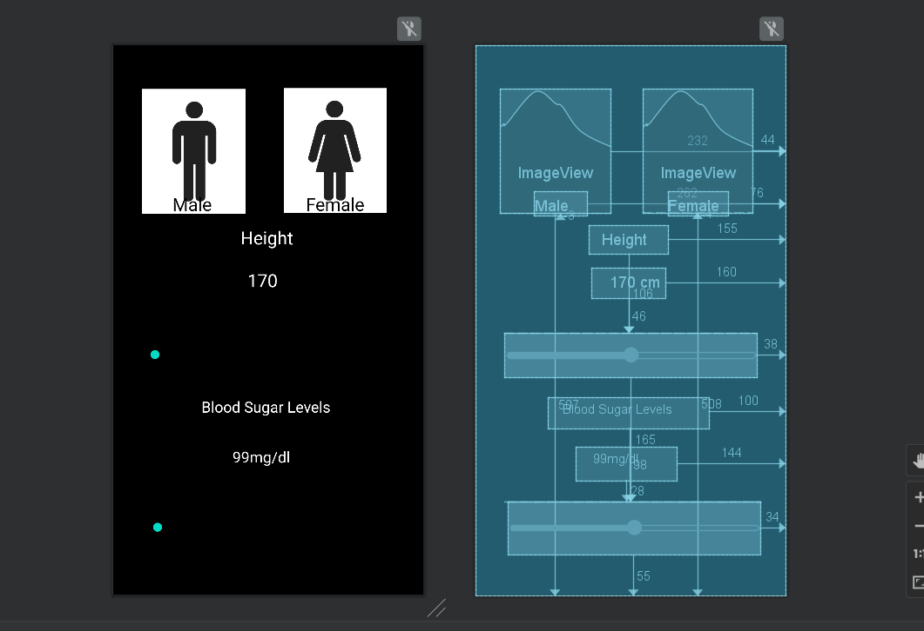

A simple and understandable interface for convenience.

Helps user to get result easily.

**15.Product test cases**

Test case for app

|  |  |  |  |  |  |  |  |  |  |  |
| --- | --- | --- | --- | --- | --- | --- | --- | --- | --- | --- |
| **Test Case ID** | | BU_001 | **Test Case Description** | | Test the access functionality in app interface | | | | | |
| **Created By** | | Anusha | **Reviewed By** | | Soham | | **Version** | | 0.1 | |
|  |  |  |  |  |  |  |  |  |  |  |
| **QA Tester’s Log** | | Review comments from Soham for application | | |  |  |  |  |  |  |
|  |  |  |  |  |  |  |  |  |  |  |
| **Tester's Name** | | Soham | **Date Tested** | | October 25, 2022 | | **Test Case (Pass/Fail/Not Executed)** | | Pass | |
|  |  |  |  |  |  |  |  |  |  |  |
| **S #** | **Prerequisites:** | | |  | **S #** | **Test Data** | | | | |
| 1 | Access to operation system | | |  | 1 | Gender = Male | | | | |
| 2 | preinstalled java and python | | |  | 2 | age =11 | | | | |
| 3 |  | | |  | 3 | blood sugar =112 | | | | |
| 4 |  | | |  | 4 | weight =120 | | | | |
|  |  |  |  |  | 5 | height =121 | | | | |
| **Test Scenario** | Verify ability of application to take input | | |  |  |  |  |  |  |  |
|  |  |  |  |  |  |  |  |  |  |  |
| **Step #** | **Step Details** | | **Expected Results** | | **Actual Results** | | | **Pass / Fail / Not executed / Suspended** | | |
|  |
| 1 | run application | | Application should open | | As Expected | | | Pass | | |  |
| 2 | Enter Data | | Data can be entered | | As Expected | | | Pass | | |  |
| 3 | Click Submit | | Data is accepted | | As Expected | | | Pass | | |  |
| 4 | Processes Data | | Data is ran through model | | As Expected but time consuming | | | Pass | | |  |
| 5 | Gives BMI | | Prints BMI | | As Expected | | | Pass | | |  |
| 6 | Gives nutritional suggestions | | output through the model | | As Expected | | | Pass | | |  |

Test case for Neural network

|  |  |  |  |  |  |  |  |  |  |  |
| --- | --- | --- | --- | --- | --- | --- | --- | --- | --- | --- |
| **Test Case ID** | | BU_002 | **Test Case Description** | | Application and functioning of neural network | | | | | |
| **Created By** | | Soham | **Reviewed By** | | Soham | | **Version** | | 0.2 | |
|  |  |  |  |  |  |  |  |  |  |  |
| **QA Tester’s Log** | |  |  |  |  |  |  |  |  |  |
|  |  |  |  |  |  |  |  |  |  |  |
| **Tester's Name** | | Soham | **Date Tested** | | November 15, 2022 | | **Test Case (Pass/Fail/Not Executed)** | | Pass | |
|  |  |  |  |  |  |  |  |  |  |  |
| **S #** | **Prerequisites:** | | |  | **S #** | **Test Data Requirement** | | | | |
| 1 | Computer | | |  | 1 | Age | | | | |
| 2 | Processor | | |  | 2 | Blood sugar | | | | |
| 3 | Gpu | | |  | 3 | BMI | | | | |
| 4 | Data | | |  | 4 | gender | | | | |
|  |  |  |  |  |  |  |  |  |  |  |
| **Test Conditions** | |  |  |  |  |  |  |  |  |  |
|  |  |  |  |  |  |  |  |  |  |  |
| **Step #** | **Step Details** | | **Expected Results** | | **Actual Results** | | | **Pass / Fail / Not executed / Suspended** | | |
|  |
| 1 | Putting data in model | | Inputs data | | As expected | | | Pass | | |  |
| 2 | Start processing of model | | processes data | | As expected | | | Pass | | |  |
| 3 | Predict outcome | | Predicts outcome | | As expected | | | Pass | | |  |
| 4 | Give Output | | Gives Output | | As expected | | | Pass | | |  |

**16.Testing result of product**

The Test cases passes successfully and hence gives appropriate output.

The testing was a success .

**17.Pass/Fail Criteria**

The criteria is to be able to give accurate response.

On giving accurate responses the case will pass or it will fail.

**18.Testing Materials**

A requirement is also a functioning device with preloaded java(preferrable).

Diet and nutrition app will most likely need a food database to let users learn nutrition details easily. For calorie counter , the testing materials required are food intake like proteins, fats ,carbs and water consumption. For BMI Calculator we need details of user’s age, height, weight and gender. For registration the details of the users are required. Daily diet and wellness tips.

Reminders to enable one to remain on track. A diary to record one’s progress. Photographs of food items.

**19.Project issues**

The project currently is in the preliminary state of development. To be put into the right use, it requires suitable platforms and recognition. Since users have become advanced, so have these applications should allow them to integrate their fitness bands with these apps. This way, they can always be able to log their food intake and physical activities done on a daily basis. But the app does not include this feature in it yet.

**20.Ideas for Solutions**

Yes they can be and will be integrated with their fitness bands with the app. This is one of our projects future development, so that after taking notes of peoples heart rate and blood pressure levels using the tracker we can be able to process a diet plan for them at that particular time. Their physical activities can also be noted like calculating a rough sketch of the person's mobility and his/her durability.

**21.Glossary**

BMI – Body mass index – method to calculate mass of body.

Macronutrients – Nutrients used in large quantity (fat,carbohydrate and protein)

**22.References/Bibliography**

[www.wikipedia.com](http://www.wikipedia.com)

<https://www.uml-diagrams.org/>

<https://www.britannica.com/science/nutrition>